24.48: a) 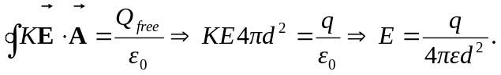
b) 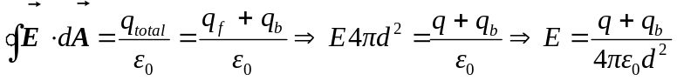
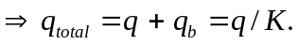
c) The total bound change is 